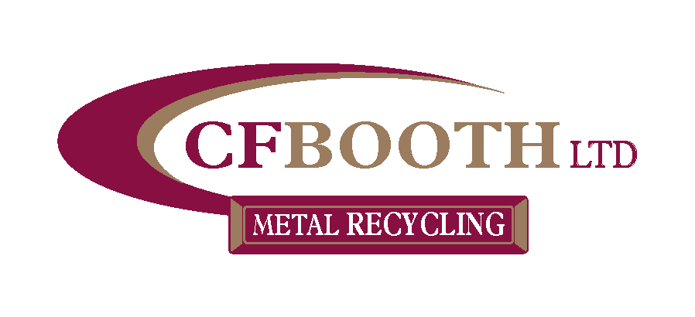

Modern Slavery and Human Trafficking Policy Statement

Modern slavery is a crime and gross violation of fundamental human rights. It takes various forms, all of which have in common the deprivation of a person's liberty by another in order to exploit them for personal or commercial gain.

We have a zero-tolerance approach to modern slavery and are fully committed to preventing slavery and human trafficking in our corporate activities. We are also committed to ensuring there is transparency in our own business and in our approach to tackling modern slavery throughout our supply chains, consistent with our disclosure obligations under the Modern Slavery Act 2015. We all have a responsibility to be alert to the risks, however small, in our business and in the wider supply chain.

This statement set outs CF Booth Limited actions to understand all potential modern slavery risks related to business and to ensure steps are maintained to prevent slavery and human trafficking.

Our Business

CF Booth Limited has grown over the years from a local metal trader into one of the largest independently run recycling companies in Europe with over 250 employees within the group and annual turnover of £115 million (2023/2024). CF Booth Limited is the head company of the CF Booth group of companies. The companies which come under this group include:
CF Booth (Doncaster) - Metal Recycling CF Booth Engineering - CNC Machining
CF Booth Stockholders - Steel Stockholders & Cutting services Northfield Aluminum - Manufacturers of Aluminum Ingots Demex Ltd - Demolition & Waste Management

Our Supply Chains and Supplier adherence to our values

The relationship with all our suppliers has been established over a number of years and is built upon mutually beneficial factors, where we have close and personal links and contact with the owners or directors, typically reflecting the fact that we partner with small, medium and large sized organisations.
As and when we have new contractors or suppliers come on-board, we pre-qualify any new firm through a series of due diligence, relating to company performance, HS&E compliance and references from other customers to establish that they are suitable.
To date, we haven't been made aware of any human trafficking/ slavery activities within the supply chain, but if any were highlighted to us then we would act immediately in accordance with our legal and moral obligations.

Our policies on slavery and human trafficking

We are committed to ensuring adhering to all relevant human rights laws and regulations and that there is no modern slavery or human trafficking in our supply chains or in any part of our business. Our Anti-slavery Policy reflects our commitment to acting ethically and with integrity in all our business relationships and to implementing and enforcing effective systems and controls to ensure slavery and human trafficking is not taking place anywhere in our supply chains. We prohibit the following:
- The use or support of practices that may inhibit the development of children
- employing anyone under the age of 16
- holding individuals or groups in slavery and servitude
- any form of involuntary labour
- trafficking of individuals or groups for the purposes of labour exploitation

Due diligence processes for slavery and human trafficking
As part of our initiative to identify and mitigate risk, we have in place systems to:
- Identify and assess potential risk areas when considering taking on new suppliers and regularly reviewing our existing supply chains.
- Mitigate the risk of slavery and human trafficking occurring in our supply chains.
- Monitor potential risk areas in our supply chain.
- Protect whistle blowers.

Training

We have zero tolerance to slavery and human trafficking. To maintain awareness and ensure a high level of understanding of the risks of modern slavery and human trafficking in our business, our Anti-slavery Policy is available in our Employee handbook and on the website.

This statement has been approved by the Board of Directors of CF Booth Limited together with all of its parent and subsidiary undertakings from time to time and is made pursuant to section 54(1) of the Modern Slavery Act 2015 and constitutes CF Booth Limited Group's Slavery and Human Trafficking Statement.

This policy is hereby authorised by:

J. H. Booth - Director
31st March 2024

